"Sky Over The Valley"  
Artist Neha Bisht / Oil on Stretched Canvas/ 36 inches × 36 inches  
______________________________  
Unexpected it rose …  
Towered above her beautiful valley.  
Weaving dreams of love, despite reality.  
Hues of autumn flamed passion red.  
Breeze blew kisses,  
Caressing the meadow, like angel's breath.

The road to dreams was beautiful.  
Sky majestic and surreal.  
The cloud was dark and glowing  
Like an alluring mystery calling.

She stood in the corner  
Gazing at the golden tinted cloud.  
Looking at the crimson trees.  
Looking at the road,  
And at the grass flaming at her feet.  
Tiny wildflowers, danced around her.  
Eyes blurred, she Looked for the signs.  
For the omens that would whisper truth.  
Waited long....

Hung in limbo, she gazed at the road.  
The road had to be walked.  
Despite dreams, despite reality.  
Despite the story in the sky over the valley.  
The road had to be walked till the end of the drop !  
______________________________  
The beauty, the passion, the darkness, the mystery, the love, the light .... It is all part of the journey. We need to understand the relevance of all. Accept all, reject nothing and walk the chosen path...

[#nehab16](https://www.facebook.com/hashtag/nehab16?source=feed_text&epa=HASHTAG)

"AN UNUSUAL SKY"  
Artist Neha Bisht  
oil on canvas/ 36inches × 36 inches (exhibit collection)  
---------------------------------------------  
"It was an unusual sky.  
Had never seen anything like it before.  
Soft in hues, raw in passion.  
It was that arresting, surreal sky,  
That heralded him into my ocean.  
A sky of love and passion,  
Over a wave that was crashing.  
He Invaded my senses.  
Took over my thoughts.  
A Golden veil penetrated the grey.  
Like a gossamer shawl, it fell on all.  
I never told him.  
Never could.  
There was a different tango about him.  
His words spoke to my soul.  
He felt like home…  
Did he feel it too ?  
Perhaps……  
I closed my eyes, to see him.  
Colours danced.  
I drowned.  
Couldn't help that too.  
The wave crashed.  
It's spray rained down my eyes.  
I was caught in a limbo.  
The unusual sky wove it's dream.  
That indescribable hue, -  
It caught my soul bad.  
It's that hue, I cannot describe.  
Of waiting and walking away from it all......  
The wave pulls me under.  
Takes me to the blues.  
It rains on me like a sweet drivel,  
Beneath the canopy of the unusual sky.  
Didn't expect that at all !!  
Didn't expect that, true!!  
_______________  
[#nehab16](https://www.facebook.com/hashtag/nehab16?source=feed_text&epa=HASHTAG)

KISS OF ELEMENTS  
Oil on Canvas/ Artist Neha Bisht /30 inches × 36 inches (exhibit collection )  
----------------------------------  
"Hey Gorgeous", he said…  
"Hi Handsome", I replied.  
The mood was set.  
Fire did not lie.  
There he stood like a dream.  
At the edge of the drop.  
Cocky & sure indeed.  
Like Lucifer, in all sweetness he beckoned.  
I sighed so deep, my peace lay threatened.  
Clouds swirled all around.  
Gathering momentum to kiss the grounds.  
If I walked to him, I knew he would vanish.  
If I walked away, all would vanish.  
Was it a chance of happiness ?  
Or another abyss ?  
I fell on my knees, looked to the heavens.  
Not a step closer.  
Not a step farther.  
Softly the skies in the distance, Lowered their passionate storm.  
They kissed the mountains.  
Shook everything around.  
Autumn grass glowed like tiny flames.  
The wind tickled my skin & ruffled my hair.  
I was frozen in the frame, with him there.  
Not wanting release…  
Not knowing what was there….  
------------------------------------------------  
A friend of mine, - a gentleman with great sense of art, aesthetics & the written word, - someone whose opinion on my art I greatly value, saw this painting and said a most beautiful thing about it. I gave him the first view of the painting and he said "Elemental - raw passion. Like the old masters. Those sea & wind paintings, you get it ? "... I felt so thrilled. All my life I have admired the Masters of European & Soviet Art. To even carry a tiny glimpse of them in my art, is heaven…

[#nehab16](https://www.facebook.com/hashtag/nehab16?source=feed_text&epa=HASHTAG)

A SUMMER BLOOM....  
Artist Neha Bisht /  
Watercolour vignettes...  
__________________________  
Outside my window it burst into a golden shower.  
Hadn't seen anything so beautiful, Sire.  
It hid the harshness of the summer sun.  
All I could see was the summer bloom.  
It enraptured my heart.  
Invaded my mind space.  
Swaying to the breeze.  
Calling & beckoning.  
Creating an illusion, so divine.  
So fragile & alluring,  
Amidst the heat & dust…..  
Skies became alive  
With a story and a song,  
They never had before.  
Perhaps he will be there,  
Perhaps he will vanish.  
A golden shower blooms outside my window.  
Air serenades like music, all around.  
Bringing in a sweet sorrow.  
Sweet sorrow of an elusive illusion.  
Like melting gold, so golden !  
___________________________

P.S. A golden Indian Summer that spreads cheer like spring. It's called Amaltaas.

[#nehab16](https://www.facebook.com/hashtag/nehab16?source=feed_text&epa=HASHTAG)

TWILIGHT SAGA  
Oil painting / Artist [Neha Bisht](https://www.facebook.com/profile.php?id=100000363773894&__tn__=%2CdK-R-R&eid=ARC7zFeXYeAhHfQSF9PekffpdegjzlvptLs4obsz7r7HhLk-x4Kvdy9ZAcPh421O5xyhAMCyfzDIvBcl&fref=mentions)  
36 inches × 36 inches (exhibit collection)  
----------------------------  
Twilight Saga.....  
"Brush moves on blank whiteness.  
Melody hums on guitar strings.  
Snatches of memories float.  
Their threads entwine with dreams & hopes.  
Surreal indigo of a twilight haze,  
Falls on every hue.  
Frantically my brush moves.  
My heart cries too.  
Cries for sense & sensibility in the indigo light.

The day had cast it's shadows.  
Shown a beautiful world.  
And all had come to pass.  
Just the way it should.  
But now,  
Night is at the doorstep.  
Morning not too far.  
But indigo washes over all.  
Twilight sings it's own song.

It brings to fore a different percept,  
On all things old & new..  
Like the last flicker, a flame rages too.  
Creating shapes in the darkness.  
I don't know if they are true.  
Time to face the last illusion.  
Face the last shadow too.  
Before the morning dawns,  
Indigo prises open, the eye of the soul.  
----------------------------------------------  
Indigo is the colour of Shiva, Third Eye Chakra. It embodies Intuition, Transformation & Ascension.

[#nehab16](https://www.facebook.com/hashtag/nehab16?source=feed_text&epa=HASHTAG)

RAIN ON MY WINDOWPANE...  
Artist [Neha Bisht](https://www.facebook.com/profile.php?id=100000363773894&__tn__=%2CdK-R-R&eid=ARDtG6MyfRTn2w01m9orERmDjCBFmfwQhYBAqhbdqUk2EZxZL15o3R4bJZAfHpC0H7-n5pqpsSwX1jJO&fref=mentions)  
Watercolour (12 × 17 inches)  
....Summer is exhausting for me. So I put my oils on hold awhile, & do a few watercolours. It is soul healing for me to connect with the fluid flow of water.  
----------------------------------------------  
...Universe had orchestrated it all.  
The meeting, the connection, love & all.  
But time had come for the curtain call.  
Time to let go of cycles redundant.  
To return to the universe that which couldn't be.  
The rain fell in stormy torrents.  
Lashing on trees, hitting the window pane.  
Did he wait awhile ?  
Was she looking ?  
They would never know.  
Rain cascaded like a watery veil.  
It felt cathartic.  
All the dust washed away.  
The oppressive heat faded.  
Kiss of rain made everything dance.  
It felt so much lighter,  
Despite the weight of water.  
Universe had orchestrated that.  
Universe orchestrated this.  
_________________________

MONSOON BALLAD.  
Artist [Neha Bisht](https://www.facebook.com/profile.php?id=100000363773894&__tn__=%2CdK-R-R&eid=ARATNa02o8NDpulLoX9bAE0Ux6CfC9FmPc2kAmFKipG9jm8JfGqkXLAIUULyQmtmbuhkgUdyJK4ImLKl&fref=mentions)  
Watercolour  
Monsoon in the air is like a story of the heart. A tango of romance. _____________________________  
Monsoon Ballad .....  
The river had meandered for long.  
Landscapes had changed.  
Rapids, waterfalls, cascading drops.  
All had been part of the journey.  
The gushing, the rush.  
The force and vigour.  
So much had happened.  
At last the meandering river,  
Came upon a bend in the forest.  
A tiny cove, where all was silent.  
She too fell silent in that tiny bend.  
Reflecting, listening to the sounds of the forest instead.  
Monsoon clouds gathered above.  
Turbulent and restless was the sky above.  
He was gathering courage to disturb her stillness.  
She knew his intention, awaited action.  
Strange it was, strange indeed.  
Water was so still, sky so dynamic.  
She knew his turbulence.  
He was intrigued by her stillness.  
Fog floated like fairies at play.  
Love was in the air -  
Perhaps….. perhaps not !  
A monsoon Ballad it was  
That danced all around.

[https://www.amazon.in/MEANDERING-BRUSH-Neha-Bi…/…/1645465055](https://l.facebook.com/l.php?u=https%3A%2F%2Fwww.amazon.in%2FMEANDERING-BRUSH-Neha-Bisht%2Fdp%2F1645465055%3Ffbclid%3DIwAR2Zs0AqUriyrAzz3iSk3M9Kbg2-m5ZRtYyV5LxSo7BcyL3DYxcdMHYUp5k&h=AT1FhYlAjSMwNQPHAHmkG3lMfH6KGg9Op63uuaPK5TxpoI3GABEWuA_7nAhAKoiEnKNuqsFn57uuZpsWvKVF9hhYC0zE-QU8yOfP7QHY2ZjOJeZfhBs8UVwoRPK4OVI7EL_iH3G3GTLHCdeBVuZC18jKfiCocAl9NA)

[#nehab16](https://www.facebook.com/hashtag/nehab16?source=feed_text&epa=HASHTAG)

AWAKENING - Artist [Neha Bisht](https://www.facebook.com/profile.php?id=100000363773894&__tn__=%2CdK-R-R&eid=ARBVXBl0DmZRDkyZabflC1c3e-SXZ4BCZS8WDV_aQhn3GQyImBN5bAnop5vaJXw6y8YV1Iz3jWdXltjs&fref=mentions)  
Watercolour... (12 × 17 inches)  
I usually do oils but of late watercolour has been calling my brushes. Water spreads on paper like tears. It kind of heals me...  
________________________  
AWAKENING...  
Dawn broke into a golden shower.  
Cool mist rose, a residue of the night.  
Warm light like a golden veil, fell.  
Sounds of the forest filled the air.  
Eyes had long been sleeping & dreaming.  
Trapped in illusions of knowing & seeing.  
With the new light, eyes opened.  
Awakened to new sensations.  
Some sounds receded.  
Some grew louder.  
Forest danced in a divine symphony.  
Wind & trees, leaves & birds…  
They seemed to speak a language I understood.  
They took me to a land far beyond.  
It was all the same, yet all was new.  
In the flush of awakening, I missed a few steps.  
Stepped on some thorns.  
Bled a few drops.  
Not to worry at all, they smiled and said.  
Lifted me up, gifted me a vision.  
Dawn broke in a golden shower.

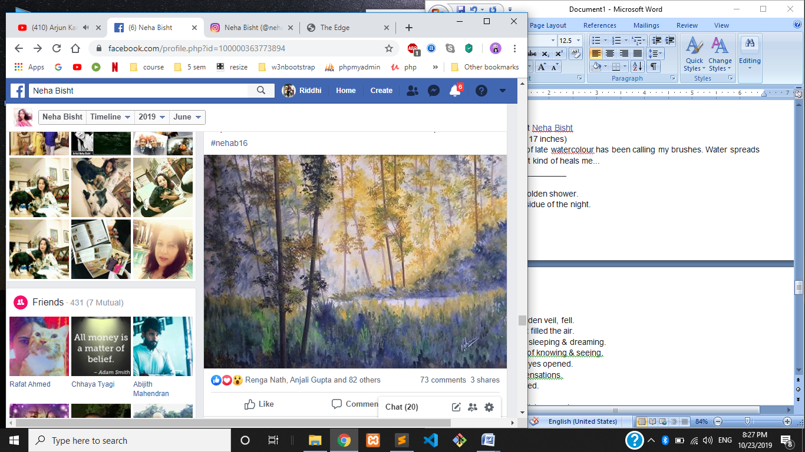

MOUNTAIN MIST  
Artist [Neha Bisht](https://www.facebook.com/profile.php?id=100000363773894&__tn__=%2CdK-R-R&eid=ARAZa6c3xAKdArdcSAZ9QHpejXZlK1_PVZ36mYBY8rDenA9OmEXWn9UE7Vj8ZdN6Mb5LUBoTrNZImhuj&fref=mentions)  
Watercolour (11.5 × 16.5 inches)  
___________________________  
It floats everywhere like angel clouds.  
Over slopes, embracing forests.  
Creating an aura of a fairytale.  
Thoughts come alive, as colours turn pale.  
Mountain mist, like a chiffon veil,  
Tantalises.  
Shows a little, adds a twist to the tale.  
Oft I sat, reading the veiled, misty pages.  
Oh! I read so many myriad stories,  
Scribbled on wafts of mist.  
Some were dreams, some memories.  
And yet, some were memories caught in a limbo of dream.  
Lost, I smiled, as mist floated around.  
Always hiding what is,  
Showing what is hidden.  
It took me to a reality that was only mine.  
Ethereal and elusive mountain mist ...  
It always carried my soul to another dimension, so swift....  
___________________________  
Those who have experienced the mountain mists, know the feeling of a timeless time travel. It is thrilling and soothing all together.  
Tippy & me, we both loved the thrill of walking into the clouds of mist.

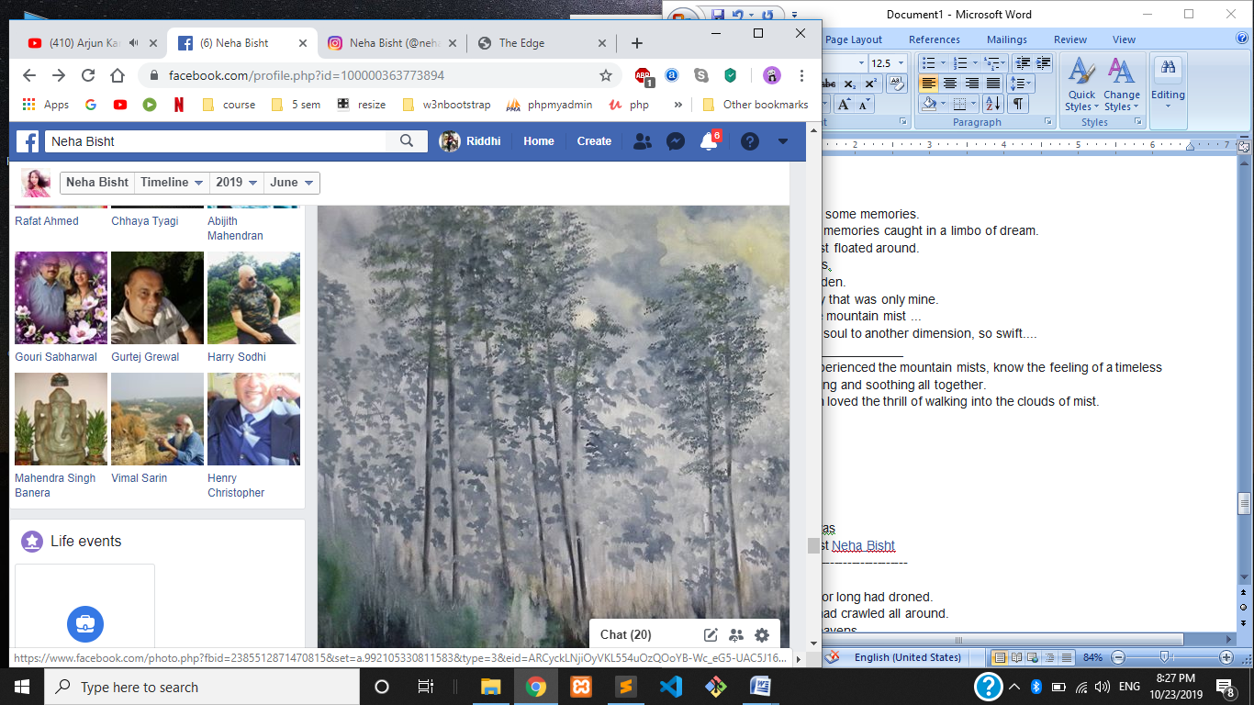

LIBERTÀ  
Oil Painting on Canvas  
(36 × 36 inches)Artist [Neha Bisht](https://www.facebook.com/profile.php?id=100000363773894&__tn__=%2CdK-R-R&eid=ARAvD8eaigg8ZPt51mH7mq5FjcKVXx_-Ul05XxNARQ0CNOCwLIZh7O7iDPTeG0slW22izQUYmRQjugZF&fref=mentions)  
----------------------------------------------  
Libertà  
Monotony of azure for long had droned.  
A restless stillness had crawled all around.  
I looked up at the heavens,  
For a letter, a message.  
Waiting…. Just waiting.  
Suddenly a tiny white tuft drifted in.  
A blade of grass poked me like a pin.  
Tuft of white changed the mood of the blue sky,  
As it floated into the line of my eye.  
Song of azure changed its rhythm.  
Excitement hummed it's tune & bubbled.  
Winds rustled the grass.  
Grew in momentum.  
Trees swayed like a song in my soul sanctum.  
Great white letters from the universe floated in the skies.  
The pulse changed as the winds kissed my eyes.  
Golden earth danced all around.  
New cycles heralded hope around.  
Spirits soared with a sense of freedom.  
Libertà, my soul cried, as it rode the skies.

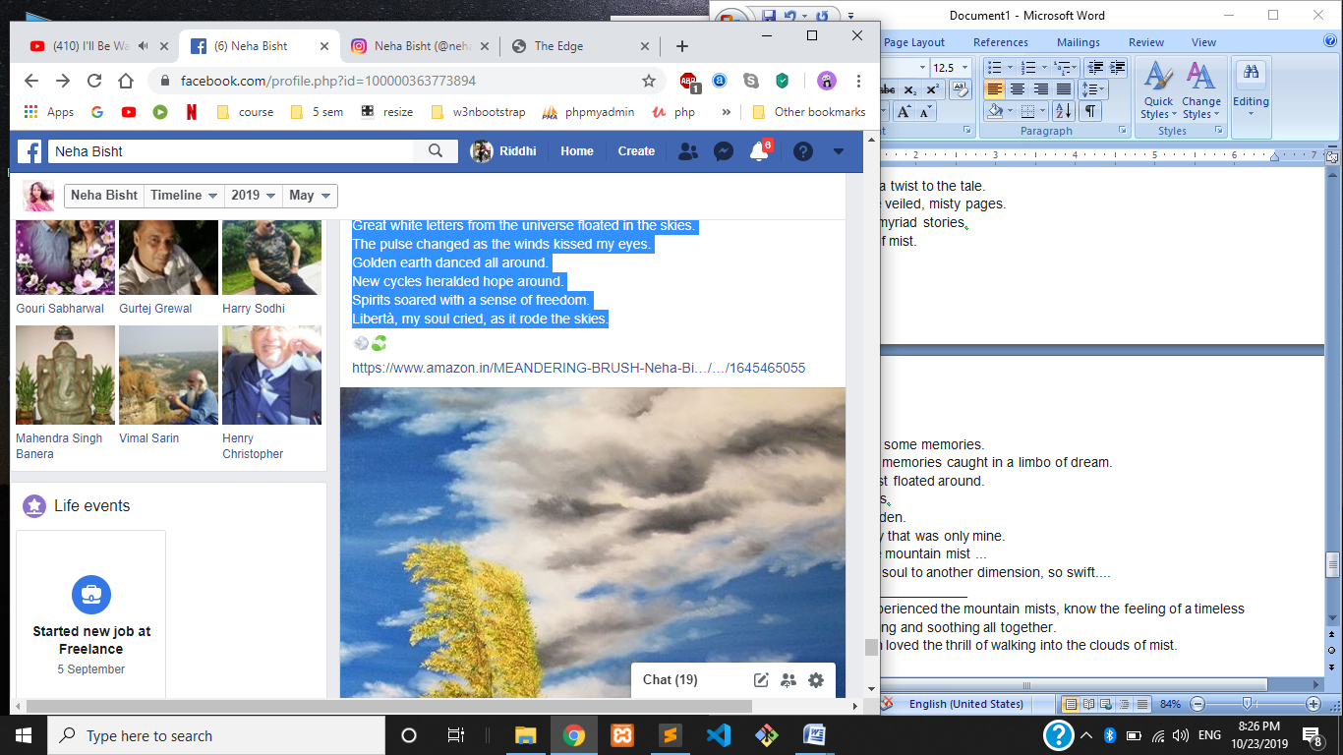

ENCHANTED... Artist [Neha Bisht](https://www.facebook.com/profile.php?id=100000363773894&__tn__=%2CdK-R-R&eid=ARCljgGOCJAMwoqmGWyZyMmh2mQlcmzUlKBCz6UhuIguQDbB5AGxE0pNHMN-wjCe4bSh-YKAH5oOPOYm&fref=mentions)  
Oil on Canvas / 36inches × 36inches  
------------------------------------------------------  
In the darkest hour she shone her light.  
Pulled and tugged at my soul all night.  
Silence was deceptive.  
Pregnant with expectation.  
Passion threatened to unleash at the edge of imagination.  
Tides rose high.  
Shadows too.  
Conscious & the Unconscious both sang their song.  
Silvery light fell on earth.  
Changed the hues to surreal emerald.  
The enchantress found me hiding.  
Hiding behind my shadow self.  
Enchanted me.  
Pulled me out on her silver rays.  
I made peace with all that I was.  
It was the hour of the Goddess,  
As she glowed in her lover's light.  
Wind and the clouds danced a charming waltz.  
Enchanted I stood in my shade of blue & emerald hues.  
------------------------------------

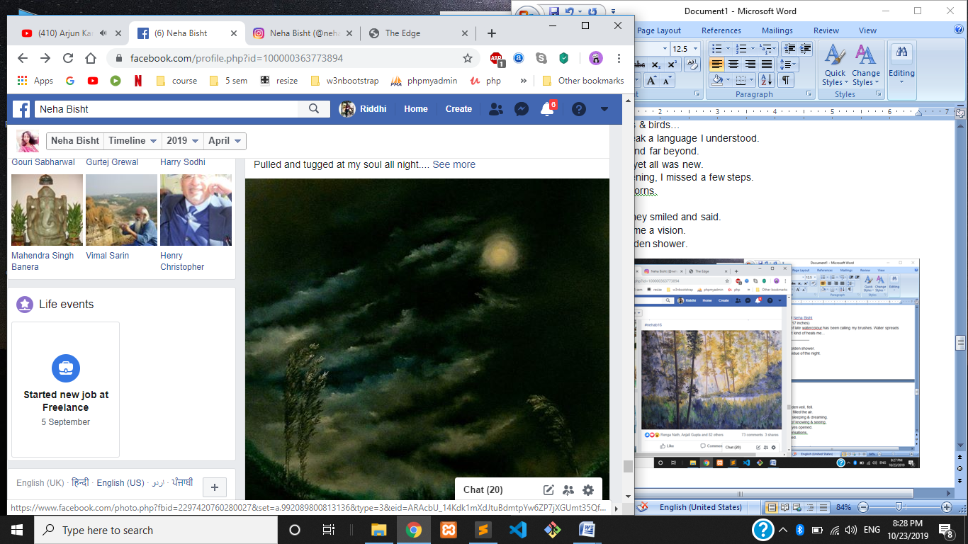

INVASION...  
Artist [Neha Bisht](https://www.facebook.com/profile.php?id=100000363773894&__tn__=%2CdK-R-R&eid=ARDfzFuK-Pv5a4LgJ3_D7Ud3fBxWTQmW1rnp-u2kgOiKC7-awj8oRD2bWV_GpAtoDCH5u-P5xXK98SWc&fref=mentions) / Oil on canvas.  
3feet x 3feet ( 36x36 inches)  
-----------------------------------  
"Darkness had shrouded for long.  
Long had fear lurked around.  
And then,  
Just when heart grew weary,  
The light broke through.  
Like dazzling arrows it pierced through.  
A glorious battle ensued.  
Invasion took place.  
Rays, like soldiers of light,  
Conquered the corners, crevices and the night.  
The weary heart woke up to a dazzling reality.  
Beauty danced on the rays of light.  
Hues & shades filled the space.  
Path to hope dazzled bright.  
A teardrop spilled out like a silent prayer.  
They saw, they heard.  
They always had.  
Soldiers of light dazzled bright.  
-----------------------------------------------------  
(... embracing the change, the unexpected, is destiny unfolding. It all happens for a reason....)

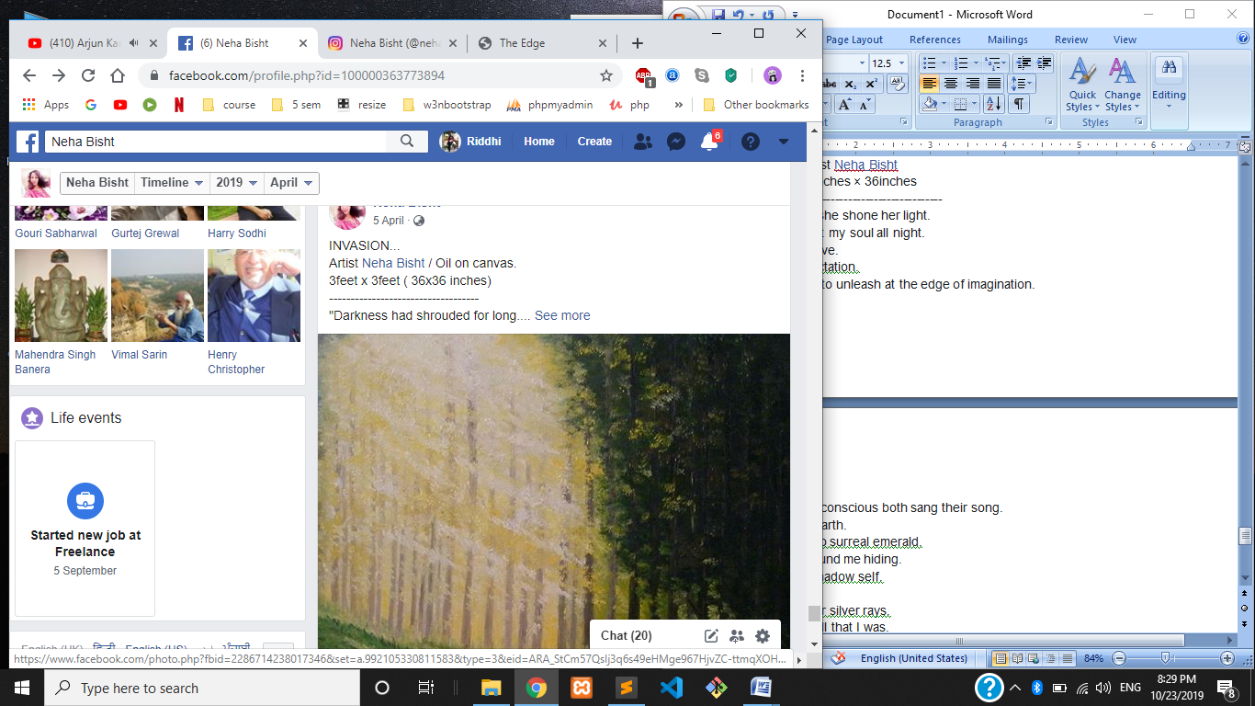

INTO THE FOG" - oil painting on canvas by [Neha Bisht](https://www.facebook.com/profile.php?id=100000363773894&__tn__=%2CdK-R-R&eid=ARDfKWl30Rt3MYkNhyxkHDXYaSthqNaxxcOJdDAf4xWX5Zz0GolTW-dUZfPreojogWbV7sgUzjhxw9D2&fref=mentions).

Sometimes in life you feel stuck. We all do. Mind races, spirit flies, dreams soar, ideas gallop, but the physical self feels shackled to situations that prevent movement. So much activity in the 4th & 5th dimensions & so little in the 3rd dimension! Frustrating !!!! It is at such moments that I recall Martin Luther King Jr's words -  
"If you can't fly then run, if you can't run then walk, if you can't walk then crawl, but whatever you do you have to keep moving forward".  
And movement happens in all spheres & dimensions. Thought is an action.

My favourite trekking path in Himalayan foothills, Lansdowne. I painted it so that I could walk on it everyday. https://static.xx.fbcdn.net/images/emoji.php/v9/t4c/1/16/1f642.png

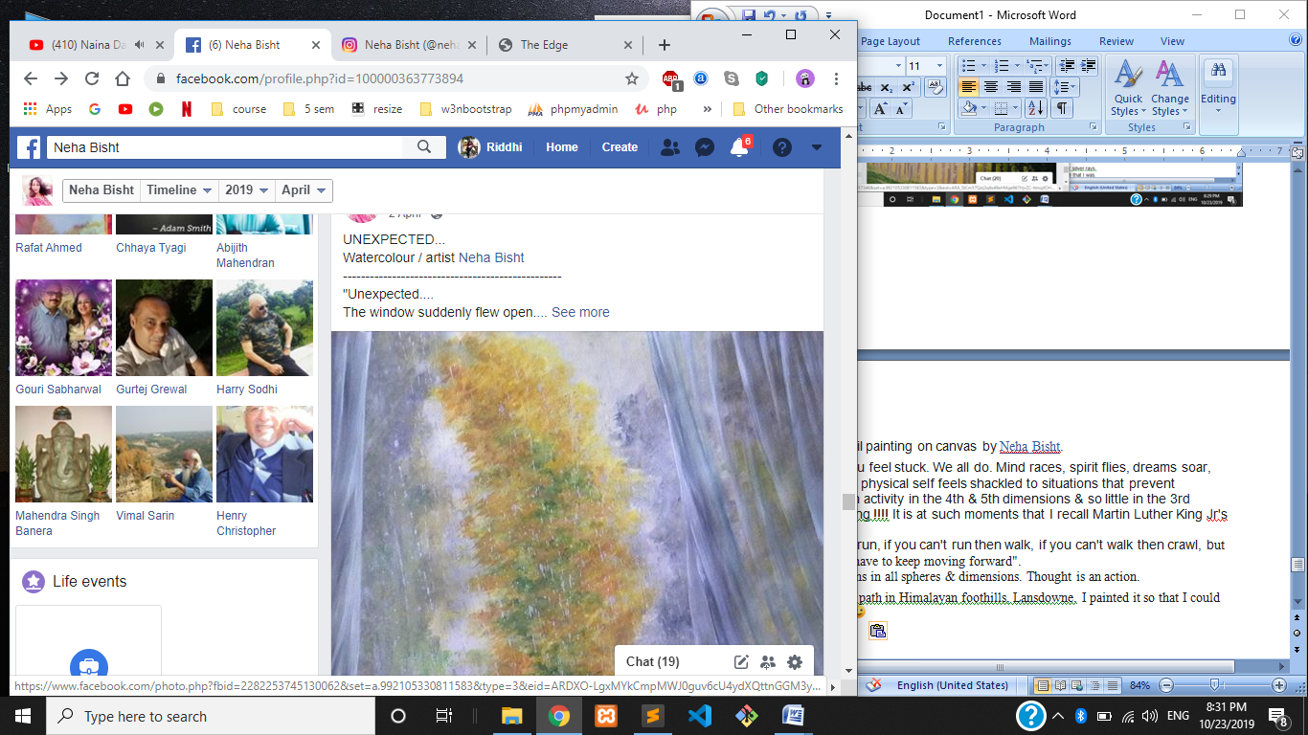

Oil painting vignette by Neha Bisht "Sometimes when I look at you, I feel I'm gazing at a distant star. It's dazzling, but the light is from tens of thousands of years ago. Maybe the star doesn't even exist any more. Yet sometimes that light seems more real to me than anything" Haruki Murakami...

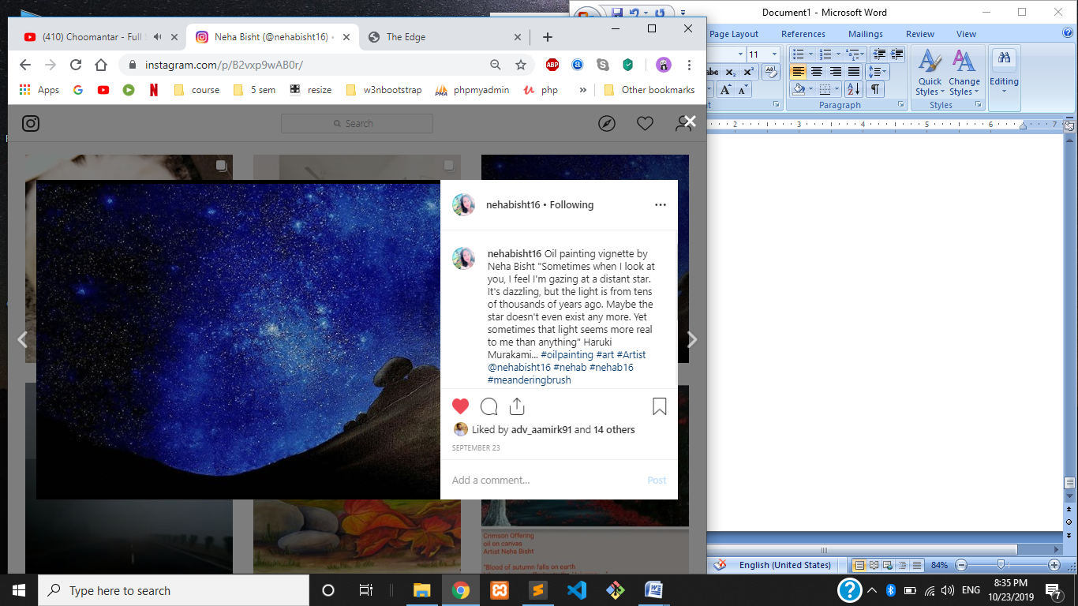

BLUE LAKE... Oil on Canvas/ Artist Neha Bisht... I have always been mesmerized by still lakes of high altitudes. Something very serene and spiritual about them. When I did this painting, I just wanted to do cloud reflections on water. The Kybalion philosophy "As above, so below" was waltzing in my mind. I referenced a few photos, added my twists & artistic liberties and composed this "Blue Lake"...  
However, when I completed it, I noticed an interesting thing. (By the way, I do reflections absolutely free hand and intuitively). On completing, I noticed an error in the picture... Specifically speaking, in the reflections. I was about to correct it, but let it go. TS Elliot's words came to mind, ....... "Between conception & creation. Between the emotion and the response, falls the shadow"... So, the error remains there. Kind of makes the painting interesting.  
Nobody has been able to catch the error till now... You wanna try 🙂  
  
This painting was also my first online upload in the year 2014

